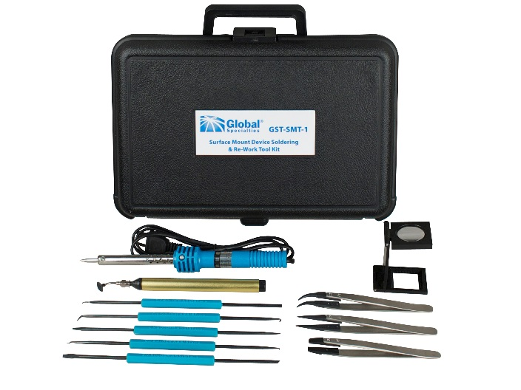

Overview:

The GST-SMT-1 is a high quality tool kit used to solder and rework surface mount devices and circuitry. The set includes 11 tools commonly used for working with surface mount components, such as anti-static tweezers with replaceable tips, suction pen with 3 different sized tips, soldering iron and magnifier. The kit comes complete in a convenient molded plastic case. The GST-SMT-1 is perfect for educational experiments, engineering and development, and repair applications.

Surface Mount Device Soldering and

Re-Work Tool Kit

Tool Kits

High quality tool kit

GST-SMT-1

© 2015 Global Specialties V20150118 22820 Savi Ranch Parkway Yorba Linda, CA 92887 1.800.572.1028