GSK-60—3 PIN REGULATED POWER SUPPLY

Many times the hobbyist wants to use a standard three terminal voltage regulator for a project, but they do not have anywhere to mount it. Usually they end up soldering an electrolytic capacitor, 100nF monoblock, switch & regulator all in a spaghetti-wired mass (mess?) and hope that it works. We have also faced this problem. We decided to overcome it by making a universal PCB to take any positive 78xx, 3 pin voltage regulator in a TO-220 package. The voltage is specified by the last two digits. The full range of fixed voltage, 3-terminal regulators is: 7805, 7806, 7808, 7809, 7812, 7815, 7818, 7820 & 7824 .
The user supplies the 3 pin voltage regulator that they want to use. We have not provided one. We have provided most of the other components needed for most common applications which you will face. You may plug in an unregulated AC or DC input either from a plug or into a terminal block. A minimum input DC voltage of at least 2 to 3 volts greater than the regulated output voltage is required for proper operation. Also there is a maximum input voltage usually specified (for example, up to 35Vdc for a 7805 to 7818 but this may result in thermal shutdown!). We suggest that the MAXIMUM input voltage used is limited to 30Vdc or 21Vac. A 1uF/35V electrolytic capacitor for C1 at the input to the regulator is sufficient for most applications. Its function is to store energy to keep input voltage ripple to a minimum between rectified pulses from the rectifier. Space has been provided for higher value capacitor if you need it, for example, if you use the 3A rated 78Txx series of regulators you may want to use a 2.2mF electrolytic. Note that a bigger heat sink may also be required if you use these higher rated regulators. The monoblock capacitor C2 across the output improves transient response and keeps the impedence low at high frequencies.

A OFF/ON switch has been provided as well as an LED to indicate when the output regulated power is online. Of course you do not have to use the LED if you do not want. **The value of the current limiting resistor R1 will change for different outputs. We have provided a 330R resistor for a 5 V regulator. Use 1K5 for 9V; 2K2 for 12V, 2K7 for 15 V, 3K3 for 18V and 4K7 for 24 V regulators

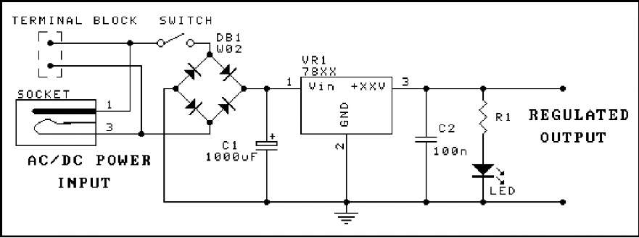
Construction. The most important point to remember is to bend the leads of the 3 terminal regulator with needle- nosed pliers. Do not just put it in the PCB & push it over 90º; that may break the IC inside the package. Put the heat sink under it before you solder it to the board. Calculate the correct value of R1 if you are going to use the LED. Make sure that the bridge rectifier and C1 are in the correct way.
Background. For most non-critical applications the best and simplest choice for a voltage regulator is the 3-terminal type. The 3 terminals are input, ground and output. The 7800 series can provide up to 1A load current and it has on-chip circuitry to prevent damage in the event of over heating or excessive current. That is, the chip simply shuts down rather than blowing out. These regulators are inexpensive, easy to use, and they make it practical to design a system with many PCBs in which an unregulated supply is brought in and regulation is done locally on each circuit board.

There is also a 79xx series of negative regulators. And we could have designed this PCB to accommodate them. However, there is so little call for regulated negative supplies these days that we decided to just design the board for the positive regulators. (Also note that the pinout for the 79 series is different to that for the 78.)
There are over 20 types of positive 3 terminal regulators available. The 78L00 series (100 mA maximum current in a transistor-type TO-92 package) and the 7800 series (1A current in TO-220AB package) are the most common for the hobbyist. The LM340T-xx series has slightly superior performance to the 78 series & can directly replace it.
The Internet is the place to find Data Sheets for individual voltage regulators. Google the regulator you want and you will find it.
COMPONENTS
330R** 5% 1/4W resistor orange orange brown | 1
100nF mono 0.1" | 1
1mF/35V ecap | 1
Power Jack | 1
Heat sink HS-110 | 1
Nut & Screw | 1 set
5mm LED | 1
Bridge Rectifier WO2M | 1
Two pole terminal block | 2
SPDT PCB-mounted switch | 1
3060 PCB | 1

