GSK-58 -- IR Toggle Switch

This is an infra-red (IR) toggle switch which we believe will work with any button on any modern remote control module. Push any button of your remote control unit and the relay in our Kit will turn on. Push any button a few seconds or hours later and the relay will toggle off.
How It Works All modern IR remote control devices produce a continuous coded stream of pulses at 37.9 kHz when any button on the module is pressed. These IR pulses are detected and decoded by a receiver (your TV, VCR etc.) and the appropriate function activated. In our Kit the coded stream is converted into a single pulse and that single pulse is used to toggle a relay on & off. The coded information is lost. Only the fact that a button was pressed on your remote control unit is detected.
This single pulse is then used to toggle the output of a flip- flop. A high on the /Q output of the flip-flop turns on transistor Q3, which in turn operates the relay and the LED. The LED provides visual indication that the relay is operating.
Circuit Description. The Kodenshi IR receiver module in our Kit detects and decodes the 37.9 kHz input as a train of negative pulses. These negative pulses are inverted by transistor Q1. Then these positive pulses are converted to a single pulse by the network R4, D1, R5 & C2. The positive pulses on the collector of Q1 charge capacitor C2 via resistor R4 and diode D1. The charging time is approximately 12.5msec (R4 x C2). During the low time between pulses the collector of Q1 is low and C2 begins to discharge. However, the discharge path is via R5 because D1 is now reverse biased and therefore non-conducting. The discharge time is about 0.5 sec (R5 x C2). Since the frequency of the received pulses is much faster than the discharge time of the capacitor C2, the capacitor cannot fully discharge before the next IR pulse train is received. The charging cycle of capacitor C2 provides the rising edge needed to clock the flip-flop.
The flip-flop (FF) is a D-type. The voltage level at the D input is transferred to the Q output on the rising edge of the clock pulse. Since we are using the inverted /Q output, a low level at D will cause /Q to go high and a high level at D will cause /Q to go low. The output of the FF can only be changed with the next rising edge of the clock input.
The /Q output which drives the relay is also fed to the D input via resistor R6 & capacitor C3. This allows the output of the FF to toggle between high and low with every clock pulse received. With /Q high, C3 is charged via R6. After about 1.2 seconds (R6 x C3) the D input will rise to a digital high level. This high will be transferred to the output on the next clock pulse. This will cause /Q to go low, thus discharging C3. After 1.2 seconds the D input will go low ready for the next clock input.
A feedback delay between the output and input is necessary to keep the input stable while clocking the FF.
The delay time chosen (1.2 seconds in this case) determines how quickly the relay can be toggled.
Power Supply. Any DC voltage in the range 8 to 15 V can be used. This voltage is regulated to 5V by Q2, R8 and ZD1. The zener diode holds the base of Q2 at 5.6 volts and Q2 conducts. The emitter voltage is equal to the base voltage less the voltage dropped across the base-emitter junction (about 0.6V). So the output is 5V. Capacitor C5 provides filtering for any high frequency noise. (Note that Q2, R8, ZD1 & C5 could be replaced by a single 5V regulator IC.)
Construction. First check that you have all the components. Check each component against the Listing given on the next page. In particular make sure you know which diode is the 1N4148 (it has 4148 printed on it in tiny numbers) and which is the 5V6 zener diode (it is packed in a compartment of the plastic bag all by itself.) Make sure to get the orientation of the diodes correct. The bar on the diode is the cathode and corresponds with the bar on the overlay printed on the circuit board.
It is generally easiest to add and solder the lowest height components first to the PCB - the resistors, diodes and monocapacitors. Then add the taller components. Pay attention to the polarization of the electrolytic capacitors and the LED. Note that Q1 is a BC558 while Q2 & Q3 are BC548's. As indicated on the overlay the dimple on the IR receiver module should be directed outwards.
Relay. We have designed the board to use a miniature, 5 pinGoodsky Brand relay AZ-SH-112L. The maximum contact load is 1A @ 110Vac/24Vdc. This on-board relay should be used to control an off-board relay or switch. It should not be used to switch mains electricity directly. The Common (C), Normally Connected (NC), and Normally Open (NO) connections are taken to a 3-pole terminal block on the right hand edge of the board.
What to do if it does not work. Poor soldering is the most likely reason that the circuit does not work. Check all solder joints carefully under a good light. Next check that all components are in their correct position on the PCB. Check the orientation of the electrolytic capacitors, transistors, diode, zener diode and the IC. Is the IR Module facing outwards?
Resistors 5%, 1/4W
680R green grey brown | R8 | 1
4K7 yellow violet red | R7 R9 | 2
27K red violet orange | R1 R2 R4 R6 | 4
100K brown black yellow | R3 | 1
1M brown black green | R5 | 1
0.47u 474 monoblok | C1 C2 C5 | 3
47u ecap | C3 C4 C6 | 3
IR receiver module |  | 1
4013 IC dual flip-flop |  | 1
14 pin IC socket |  | 1
5mm red LED |  | 1
Miniature relay AZ-SH-112L |  | 1
BC548 | Q2 Q3 | 2
BC558 | Q1 | 1
1N4148 | D1 | 1
1N4004 | D2 | 1
Zener diode 5V6 |  | 1
2 pole edge connector |  | 1
3 pole edge connector |  | 1
3058 PCB |  | 1

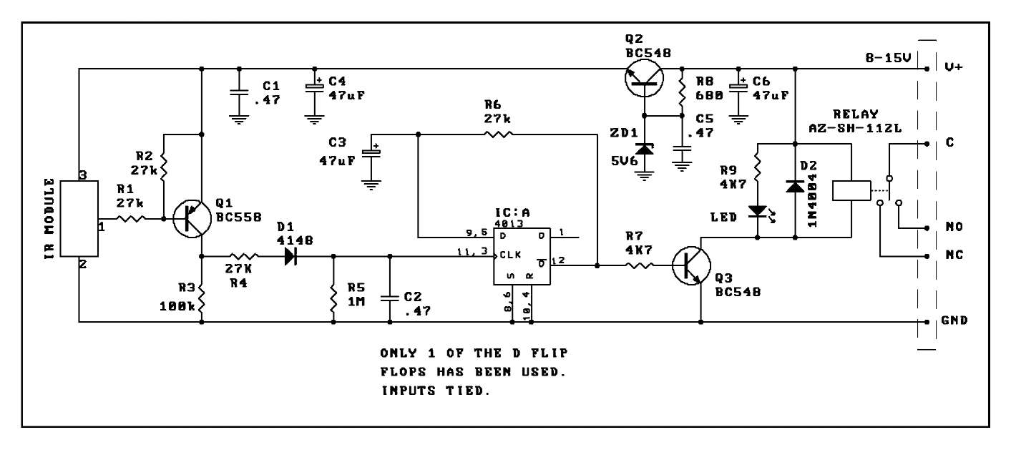

GENERAL RELAY INFORMATION
Warning! Risk of Electric Shock!
Some kits and modules have 110-240Vac mains rated relay outputs (as specified in the Product Documentation). Controlling mains equipment using these relay outputs must be treated with extreme caution. Electric shocks can cause severe and permanent injury or even death. Construction, installation, testing and commissioning should only be attempted by suitably qualified persons, or under the supervision of a suitably qualified person. These products are not suitable for children.
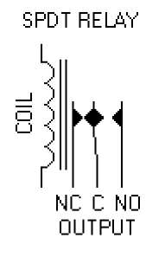

Before connecting mains powered equipment to the relay outputs please check with the relevant authorities in order to ensure compliance with all current local safety requirements. Many areas of the assembly may operate at mains voltage. A suitable isolating enclosure must be used. Exposed screw terminal blocks on some products must be insulated to prevent contact with exposed metallic parts at mains potential. Connected equipment should be suitably fused.
You will find relay outputs on many of the kits and modules that we sell. A relay is simply an electrically operated on/off switch. It is important that you observe the relay voltage and current limitations specified in the Product Documentation (not all products are rated to switch mains power even though the relays supplied may state higher voltage and current limits!)
Relay Terminals
Most boards have SPDT (Single Pole Double Throw) style relays. These have three outputs: C = Common
NO = Normally-Open contacts connect the circuit when the relay is activated; the circuit is disconnected when the relay is inactive. It is also called a Form A contact or "make" contact.
NC = Normally-Closed contacts disconnect the circuit when the relay is activated; the circuit is connected when the relay is inactive. It is also called a Form B contact or "break" contact.

Connecting the Device you want to Control
You must provide an external power source to the device you want to control. No voltage is present at the relay terminals (remember it is just a switch). The relay is normally connected in series with the positive (+) power wire of the device you want to control.
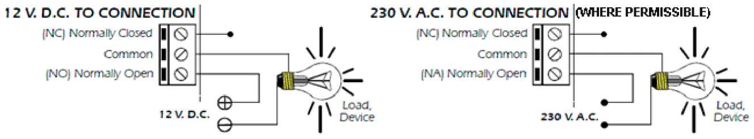
In this case, the positive wire from the power source should be connected to Common. Then either the NO or NC terminal (as appropriate for your purpose) is connected to the positive (+) wire going to the device you want to control. The negative (-) wire does not connect to the relay at all. It goes directly from the power source negative output to the device negative (-) terminal.

Typical SPDT Relay Connection Diagrams

Anti-Spark SPDT Relay Connection Diagram
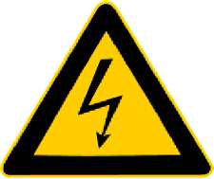
Sometimes the connected equipment can cause arcing across the relay contacts. This must be corrected by installing a resistor and capacitor (not supplied) between the two contacts of the relay as shown below. Component values are for 230Vac mains.

