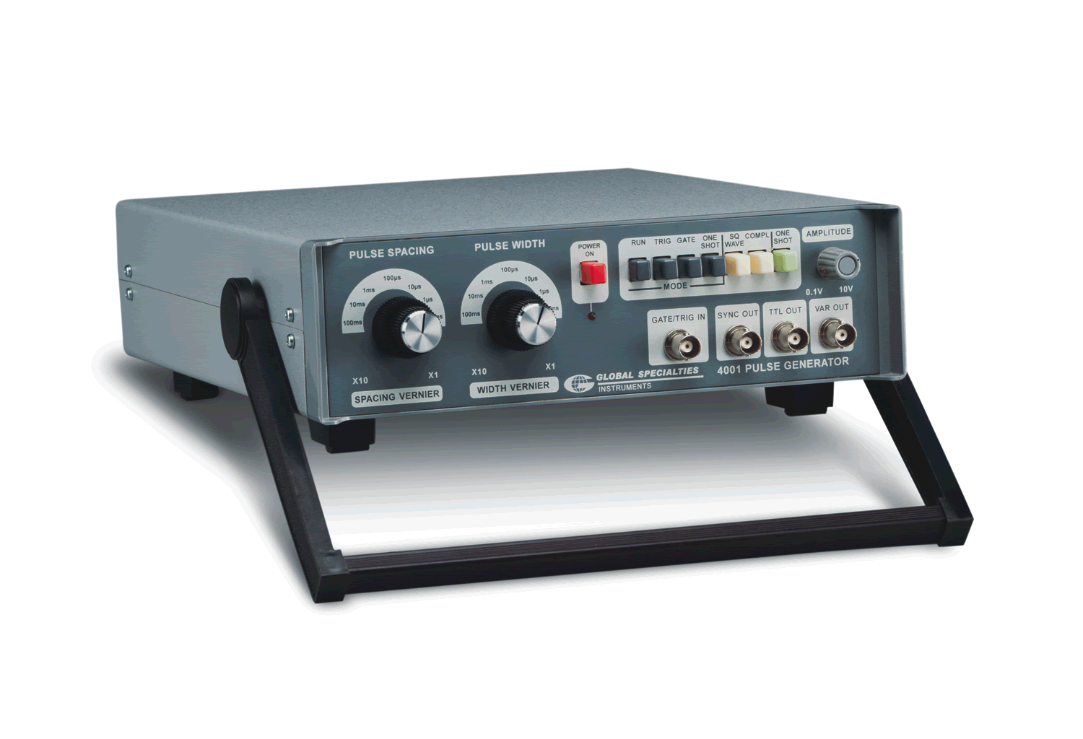

|  |  |
| --- | --- |
| **Specifications** | |
| Sensitivity | Trigger/Gate, DC couples, BNC connector, TTL compatible 40 ns wide, >2.4 Vpk or sine wave >1.7 Vrms |
| Outputs | 3 outputs, DC coupled, BNC connector |
| VAR Impedance | Constant 50 Ω |
| VAR Amplitude | 0.5-10 V into open circuit, 0.25-5.0 V driving 50 Ω, variable with amplitude control, rise/fall time less than 30 ns |
| TTL Drive | Standard TTL levels, buffered to drive up to 40 TTL loads, rise/fall time less than 20 ns |
| SYNC | +2.4V (TTL compatible pulse, buffered to drive min. 10 TTL loads) |
| SYNC Timing | 20 ns pulse width, leads main outputs by >20 ns, rise/fall less than 20 ns |
| Run | 0.5 Hz to 5 MHz continuous output pulse train; pulse width, spacing independently variable 100 ns to 1 s with 10:1 verniers over seven decade ranges, accurate ±5%, calibrated at min., max. settings; jitter under 0.1% ±5 ps |
| Trig | Pos edge of Trigger input, DC to 10 MHz, crossing 1 V threshold triggers single pulse, width determined by pulse width controls |
| Power | 120 VAC, 60 Hz, 6 VA max (220 VAC, 50 Hz version available) |
| Dimensions (W x H x D) | 10 x 7 x 3 in (254 x 178 x 76 mm) |
| Weight | 2.2 lbs. (1.0 kg) |

Overview:

The 4001 is designed to permit precise tailoring of pulse repetition rates and duty cycles over a wide range through the independent setting of pulse width and pulse spacing. Both are continuously variable over seven decade ranges from 100 ns to 1 s, with outputs from 0.5 Hz to 5 MHz. Four front panel push-button selectable operating modes can be used to produce a pulse train or enable a single output pulse. Pulse duration is determined by width control. Use the 4001 as a missing-pulse detector, to trace digital logic flow, to analyze microprocessor programs, for testing radio control receivers, or many other applications requiring a precision pulse source.

Product

Features:

Four modes: run, triggered, gated, one-shot

Symmetrical square wave outputs

Variable output for CMOS circuits

Two simultaneously independent outputs (TTL and variable) with rise and fall times less than 30 ns

5 MHz Ultra-Variable Pulse Generator

4001

© 2015 Global Specialties V20150108 22820 Savi Ranch Parkway Yorba Linda, CA 92887 1.800.572.1028